**Locating child with CSS path**

We can locate the first, last and nth child elements by using

**1. *:first-child**

**2. *:last-child**

**3. *:nth-child(Number)** notations in CSS path.  
  
**Examples:**  
  
**body  > *:first-child**    -> Locates the first child element under the body tag  
**body > *:last-child**      -> Locates the last child element under the body tag  
**body > *:nth-child(2)**   -> Locates the 2nd child element under the body tab

# Type 1

Click on the 'Firepath' tab, select the CSS option, enter the CSS path **body > *:first-child** into the text box as shown below and click on 'Eval' button:

[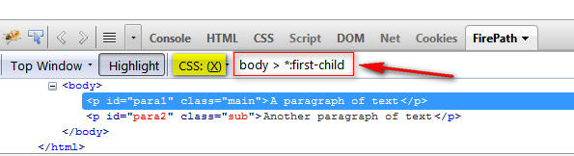](http://2.bp.blogspot.com/-uDcoqoVX8TU/UXkT9b_4kqI/AAAAAAAASCA/V9xeqEj4RxA/s1600/4.jpg)

# Type 2

Click on the 'Firepath' tab, select the CSS option, enter the CSS path **body > *:last-child** into the text box as shown below and click on 'Eval' button:

[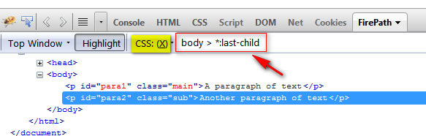](http://2.bp.blogspot.com/-lyBy7knyj4s/UXkUyyt4JeI/AAAAAAAASCU/HN70THXgkIU/s1600/6.jpg)

Type 3:

 Click on the 'Firepath' tab, select the CSS option, enter the CSS path **body > *:nth-child(2)** into the text box as shown below and click on 'Eval' button:

[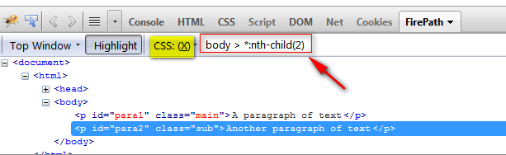](http://3.bp.blogspot.com/-g0rcORwhROw/UXkVkPaAnII/AAAAAAAASCk/Q-NiQPWkpTU/s1600/8.jpg)

# Type 5

Click on the 'Firepath' tab, select the CSS option, enter the CSS path **head > *:first-child** into the text box as shown below and click on 'Eval' button:

[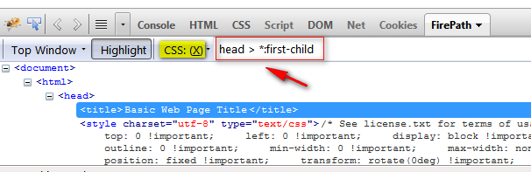](http://4.bp.blogspot.com/-xdhDFMOcWJU/UXkX1jrvz3I/AAAAAAAASC8/v9Aa2wBkW_I/s1600/10.jpg)